MATHEMATICS

This study is designed to provide access to worthwhile and challenging mathematical learning in a way that takes into account the needs and aspirations of a wide range of students. It is also designed to promote students' awareness of the importance of mathematics in everyday life in an increasingly technological society, and confidence in making effective use of mathematical ideas, techniques and processes.
All students in all the mathematical units offered would apply knowledge and skills, model, investigate and solve problems, and use technology to support learning mathematics and its application in different contexts.
The choice of the Mathematics subjects to be studied by any individual student is critical. Whilst it is not a requirement that students study Mathematics to gain the V.C.E., once a student has chosen to study Mathematics, the units to be tackled must be considered very carefully. As a result, it is vital that students discuss their selections with some or all of the following: Mathematics Teachers, VCE Coordinator, Careers Coordinator, potential employers and parents.

Equipment
Students studying any of the Mathematics subject listed below, with the exception of Foundation Maths, will need a Ti-nspire CAS calculator.

Structure
The study is made up of the following units:
- Foundation Mathematics Units 1 and 2
- General Mathematics Units 1 and 2
- Mathematical Methods Units 1 and 2
- Specialist Mathematics Units 1 and 2
- Further Mathematics Units 3 and 4
- Mathematical Methods Units 3 and 4
- Specialist Mathematics Units 3 and 4
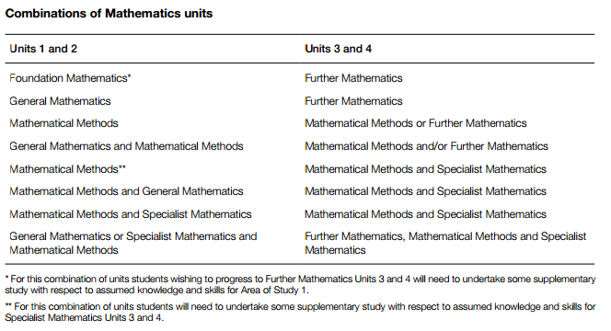Entry
There are no prerequisites for entry to Units 1, 2 and 3; however, students undertaking Mathematical Methods Units 1 and 2 or Specialist Mathematics Units 1 and 2 are assumed to have a sound background in number, algebra, function, geometry, probability and statistics. Students must undertake Unit 3 prior to undertaking Unit 4. Units 1 to 4 are designed to a standard equivalent to the final two years of secondary education. All VCE studies are benchmarked against comparable national and international curriculum. Enrolment in Specialist Mathematics Units 3 and 4 assumes a current enrolment in, or previous completion of, Mathematical Methods Units 3 and 4. There are no restrictions on the number of units students may obtain credit towards satisfactory completion of the VCE.

Levels of achievement Units 1 and 2
Procedures for the assessment of levels of achievement in Units 1 and 2 are a matter for school decision. Assessment of levels of achievement for these units will include routine class activities, assignments, topic tests and semester exams.

Levels of achievement Units 3 and 4
Further Mathematics
Unit 3 School-assessed Coursework: 20 per cent
Unit 4 School-assessed Coursework: 14 per cent
Units 3 and 4 Examination 1: 33 per cent
Units 3 and 4 Examination 2: 33 per cent

Mathematical Methods
Unit 3 School-assessed Coursework: 17 per cent
Unit 4 School-assessed Coursework: 17 per cent
Units 3 and 4 Examination 1: 22 per cent
Units 3 and 4 Examination 2: 44 per cent

Specialist Mathematics
Unit 3 School-assessed Coursework: 17 per cent
Unit 4 School-assessed Coursework: 17 per cent
Units 3 and 4 Examination 1: 22 per cent
Units 3 and 4 Examination 2: 44 per cent

Examination 1 for Mathematical Methods and Examination 1 for Specialist Mathematics are technology free examinations. Examinations 1 and 2 for Further Mathematics, Examination 2 for Mathematical Methods and Examination 2 for Specialist Mathematics assume student access to VCAA approved technology.

Units 1 and 2: Foundation Mathematics

In Foundation Mathematics there is a strong emphasis on the use of mathematics in practical contexts encountered in everyday life in the community, at work and at study. The areas of study for Units 1 and 2 of Foundation Mathematics are ‘Space, shape and design’, ‘Patterns and number’, ‘Data’ and ‘Measurement’.

Units 1 and 2: General Mathematics

General Mathematics provides for different student interests; developing both practical mathematics skills and preparing students for Units 3 and 4 Further Mathematics. The areas of study for General Mathematics Unit 1 and Unit 2 are ‘Algebra and structure’, ‘Arithmetic and number’, ‘Discrete mathematics’, ‘Geometry, measurement and trigonometry’, ‘Graphs of linear and non-linear relations’ and ‘Statistics’.

Unit 1 and 2: Mathematical Methods (CAS)
Mathematical Methods Units 1 and 2 provide an introductory study of simple elementary functions of a single real variable, algebra, calculus, probability and statistics and their applications in a variety of practical and theoretical contexts. They are designed as preparation for Mathematical Methods Units 3 and 4 and contain assumed knowledge and skills for these units.

Unit 1 and 2: Specialist Maths
Mathematical Methods Units 1 and 2 and Specialist Mathematics Units 1 and 2, taken in conjunction, provide a comprehensive preparation for Specialist Mathematics Units 3 and 4. The areas of study for Units 1 and 2 of Specialist Mathematics are ‘Algebra and structure’, ‘Arithmetic and number’, ‘Discrete mathematics’, ‘Geometry, measurement and trigonometry’, ‘Graphs of linear and non-linear relations’ and ‘Statistics’.

Units 3 and 4: Further Mathematics
Further Mathematics consists of two areas of study, a compulsory Core area of study to be completed in Unit 3 and an Applications area of study to be completed in Unit 4. The Core comprises ‘Data analysis’ and ‘Recursion and financial modelling’. The Applications area of study comprises two modules from a selection of four possible modules: ‘Matrices’, ‘Networks and decision mathematics’, ‘Geometry and measurement’ and ‘Graphs and relations’.

Unit 3 and 4: Mathematical Methods (CAS)
Units 3 and 4 consist of the areas of study ‘Functions and graphs’, ‘Calculus’, ‘Algebra’ and ‘Probability and statistics’, which must be covered in progression from Unit 3 to Unit 4, with an appropriate selection of content for each of Unit 3 and Unit 4. Assumed knowledge and skills for Mathematical Methods Units 3 and 4 are contained in Mathematical Methods Units 1 and 2, and will be drawn on, as applicable, in the development of related content from the areas of study, and key knowledge and skills for the outcomes of Mathematical Methods Units 3 and 4.

Unit 3 and 4: Specialist Mathematics
Specialist Mathematics Units 3 and 4 consist of the areas of study: ‘Functions and graphs’, ‘Algebra’, ‘Calculus’, ‘Vectors’, ‘Mechanics’ and ‘Probability and statistics’. Specialist Mathematics Units 3 and 4 assumes familiarity with the key knowledge and skills from Mathematical Methods Units 1 and 2, the key knowledge and skills from Specialist Mathematics Units 1 and 2 topics 'Number systems and recursion' and 'Geometry in the plane and proof', and concurrent or previous study of Mathematical Methods Units 3 and 4.

