AGRICULTURAL AND HORTICULTURAL STUDIES

Australia is reliant on its primary industries. The sustainable management of Australia’s finite land and water resources is vital for the continued production and supply of food and fibre to local, national and global markets.

Work in the Agriculture and Horticulture sectors does not only involve farming but also many support roles such agronomy, scientific research and marketing.

VCE Agricultural and Horticultural Studies is designed to develop students’ understanding of the operations and practices involved with sustainable agricultural and horticultural systems within an economic, social and environmental context. An understanding of agribusiness operations involves a broad familiarity with interdisciplinary skills and knowledge of technology, science, economics and business management, marketing, geography and information and communications technology.

The study is made up of four units:
There are no prerequisites for entry to Units 1, 2 and 3. Students must undertake Unit 3 prior to undertaking Unit 4.

All four units include the planning, management and evaluation of a business project involving the care and monitoring of living plants or animals.
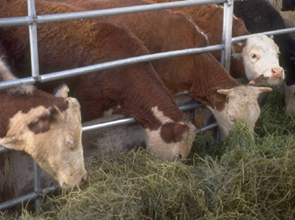
Unit 1: Agricultural and horticultural operations
Focus: Developing an understanding of how the biological and physical components of the environment and human resources influence the type of agribusinesses undertaken at particular locations. Topics include classification, photosynthesis, soils and climate.

Unit 2: Production
Focus: Building basic knowledge of the nutritive and reproductive processes of plants and animals, and specific biological and environmental factors that influence production systems. Topics include digestion, genetics and production systems.

Unit 3: Technology, innovation and business practices.
Focus: Students study the management of soil & growing media, water, weeds and pests & diseases of plants and animals. They investigate new and emerging technologies.

Unit 4: Sustainable management
Focus: Students develop an understanding of the importance of identification, rectification and prevention of environmental degradation for the sustainability of agribusinesses. They consider the effects of climate change and how business responds to these effects. Students consider strategies for economic, social and environmentally sustainable resource management within agriculture and horticulture.

Assessment:
Satisfactory Completion: Demonstrated achievement of the set of outcomes specified for each unit.
Levels of Achievement
Unit 1 and 2: Graded assessment tasks (A to E) for each outcome.
Unit 3 and 4: School-assessed coursework and an end-of-year examination
- Units 3 & 4 school-assessed coursework: 33 per cent each
- Examination: 34 per cent.

