*“Art washes away from the soul the dust of everyday life”* Picasso

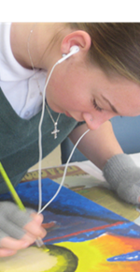

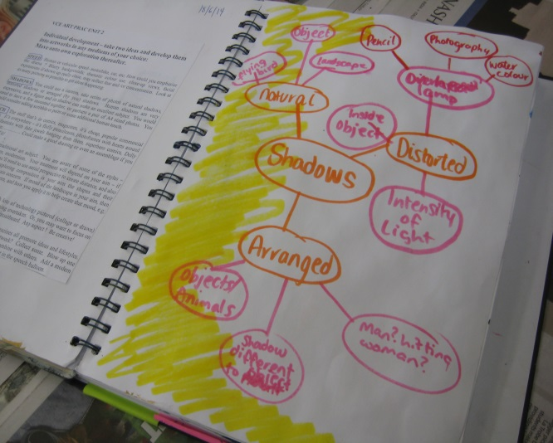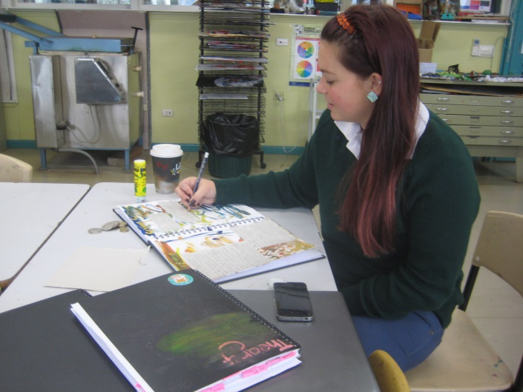

VCE Prac students work on self-chosen themes

Art involves pursuit of a practical areas of personal interest, be it drawing, painting, printmaking, collage, photography, film-making, ceramics, sculpture or mixed media. Students develop ideas and themes and record this development in a Visual Diary. In Units 3 and 4 this book forms a folio of practical work. All Art units involve theory study and practical work.

**UNIT 1**

* Artmaking and personal meaning (Practical)
* Art and Meaning (Theory)

**UNIT 2**

* Artmaking and cultural expression (Practical)
* Art and culture (Theory)

**UNITS 3 and 4**

* Investigating & resolving personal ideas through artmaking (Practical)
* Interpreting, discussing and debating Art (Theory)

There are no prerequisites for Units 1, 2 and 3. Students must undertake Unit 3 prior to Unit 4.

**Assessment** comprises tasks of school-assessed coursework (10%) in Units 3 and 4, school-assessed tasks in Units 3 and 4 equaling 50%, and an examination worth 30% of the total score.

