VCE - DRAMA
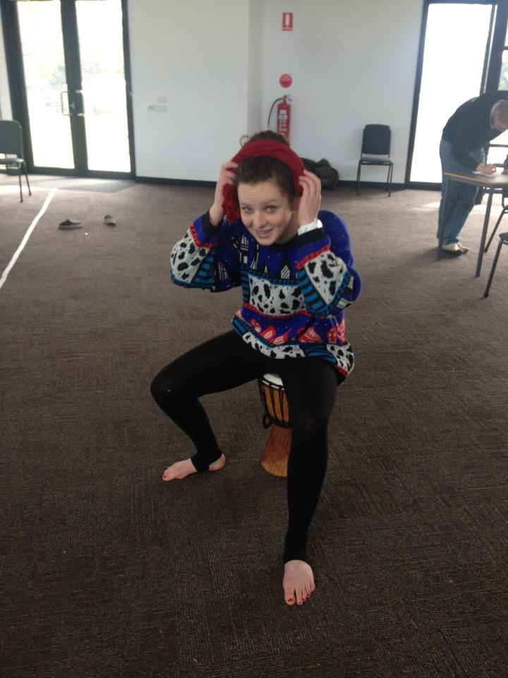
UNIT 1 and 2: DRAMATIC STORYTELLING and CREATING AUSTRALIAN DRAMA

Students examine storytelling through the creation of ensemble performances and develop expressive skills to present their characters. Students develop an understanding of naturalistic and non-naturalistic performance styles. They investigate a range of stimulus material and learn about stagecraft, theatrical conventions and performance styles. Students also analyse their own performance and are involved in the analysis of other professional performers.
Students use a range of stimulus material to create a performance based on a person, an event, an issue, a place, an art work, a text and/or an icon from a contemporary or historical context.
Students present their performances to a live audience of their devised drama on an historical context.
Students also focus on reflecting and articulating the work processes involved and continue to develop their use of drama terminology.

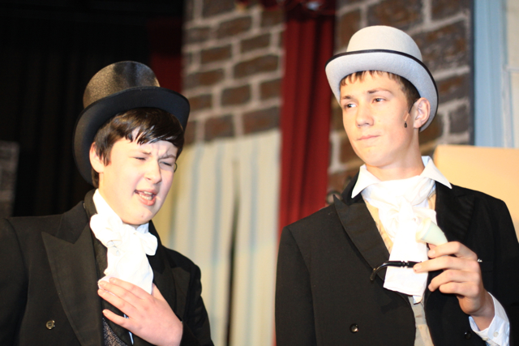
ASSESSMENT: There are a range of assessment tasks ranging from performance examples, folios and recording of processes used to essay style questions. There is also a mid year exam.

Unit 3 and 4 – Ensemble and Solo Performance.

Ensemble - In Unit 3 we will focus on non-naturalistic drama from a range of contemporary and cultural performance traditions.
Students explore non-naturalistic styles and conventions in the creation, development and presentation of an ensemble performance. They use and manipulate dramatic elements, expressive skills and performance styles to enhance their performance and document and evaluate the stages in the development and presentation of the ensemble performance. Students explore non-naturalistic dramatic form through the creation of an ensemble performance. Non-naturalistic drama uses performance styles that are not dependent on life-like representations.
Students describe, reflect upon, interpret, analyse and evaluate the construction and performance of an ensemble performance using the language of drama to discuss their own work.
Students analyse ways characters are represented in the performance through the use of expressive skills. They also consider the manipulation of dramatic elements, theatrical conventions and stagecraft.

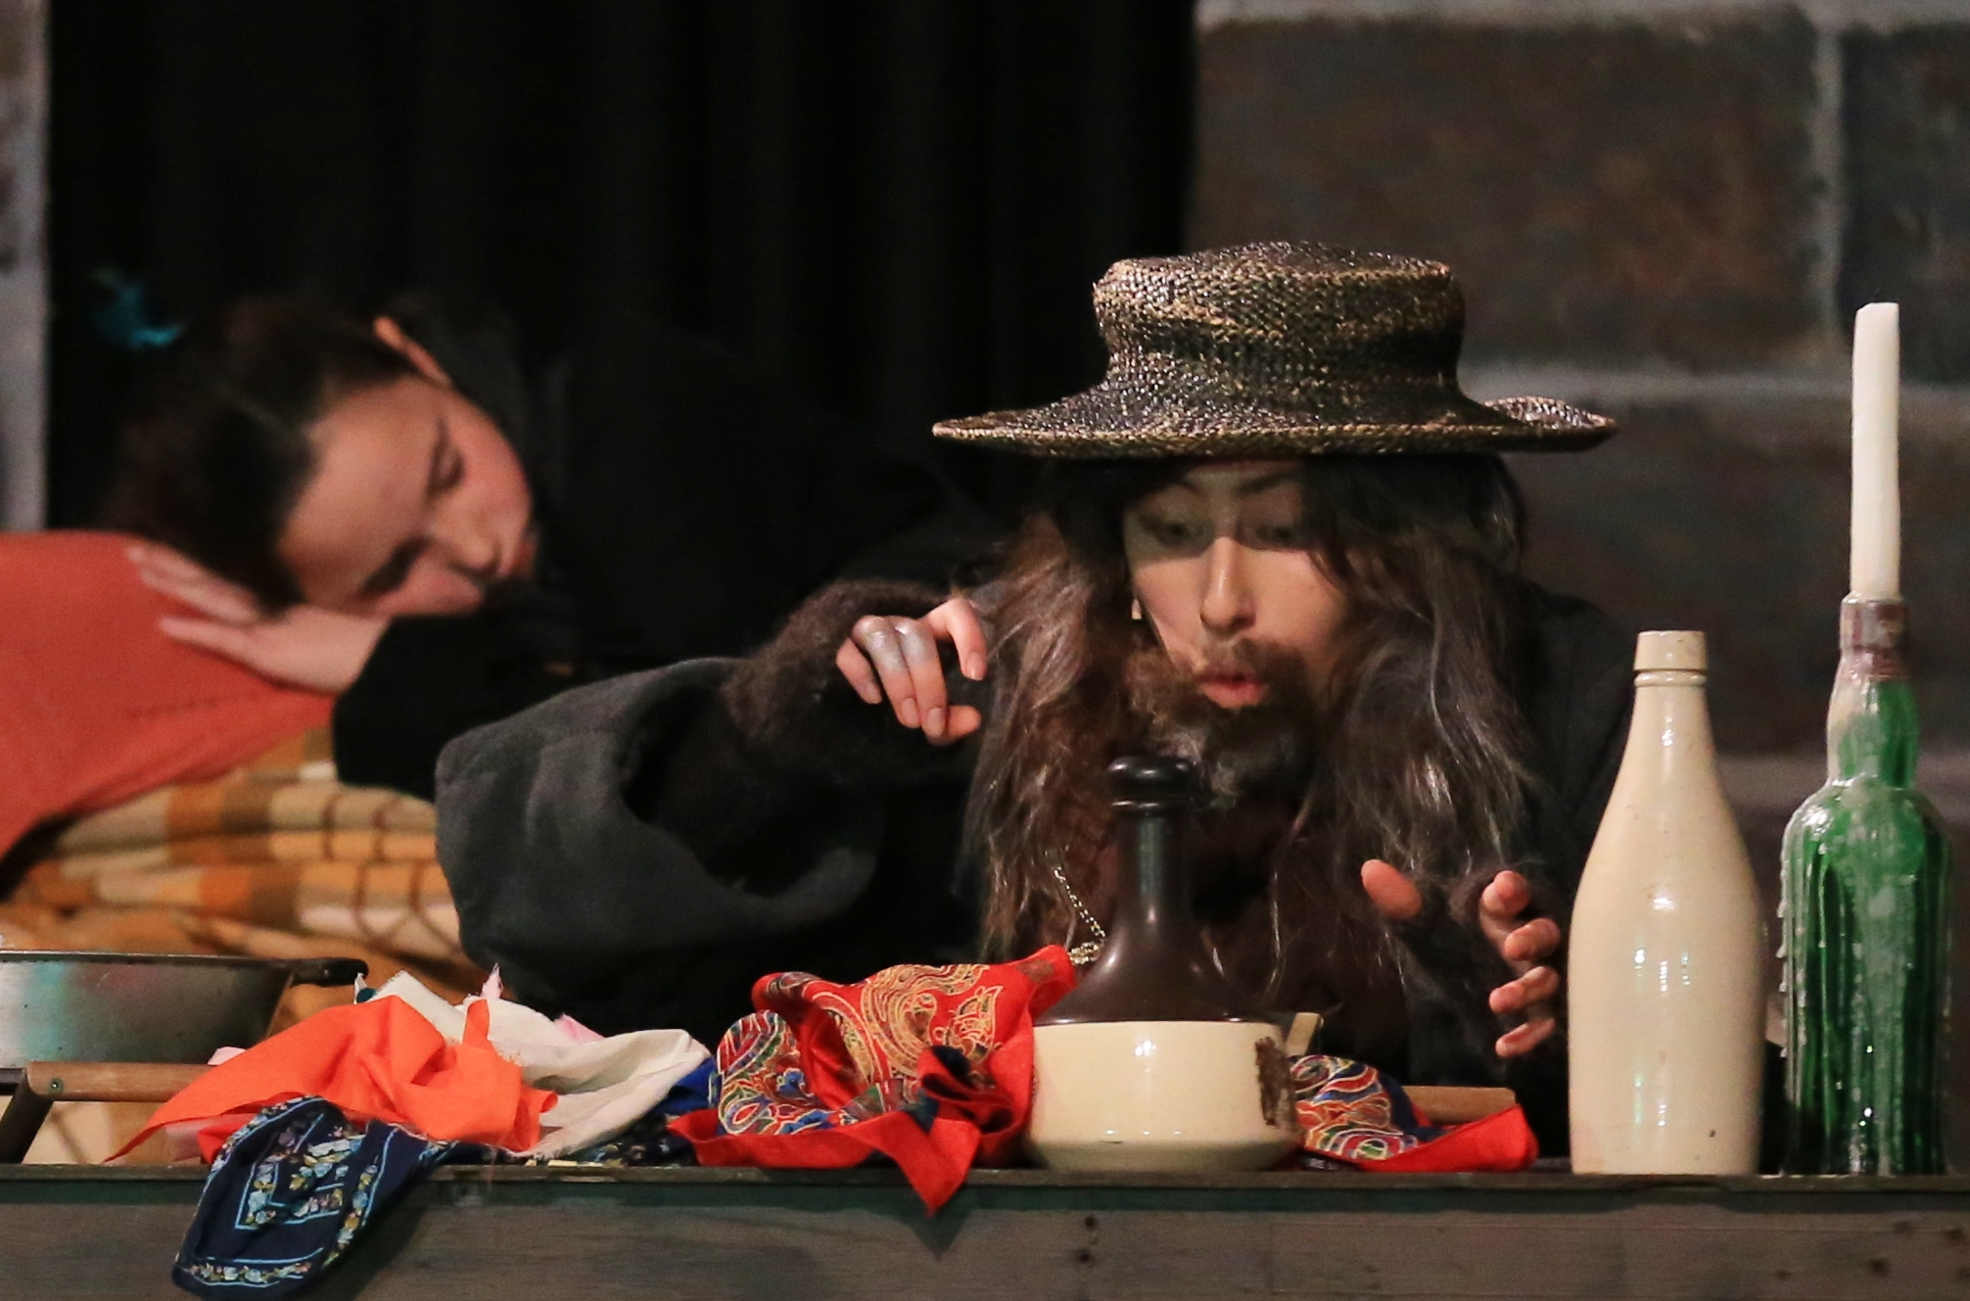
Solo Performance – In Unit 4 we focus on the use of stimulus material and resources from variety of sources to create and develop character/s in a solo performance. Students create and perform a short solo performance based on stimulus material, and evaluate the processes used.
Performance examination
Students create, develop and perform a character or characters within a solo performance in response to a prescribed structure. Students draw on their understanding of traditions of performance from a range of historical, cultural and social contexts.

Written Examination
One and a half hours involving a series of questions requiring short and extended responses.
It will require students to develop ideas from stimulus material including dramatic elements, performance styles and theatrical conventions.

