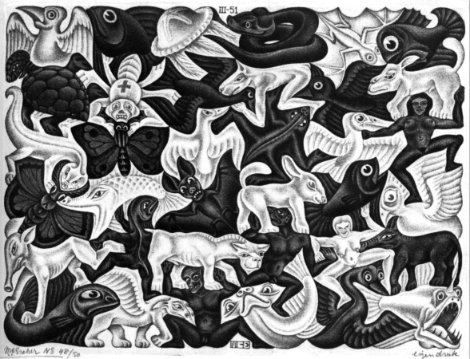
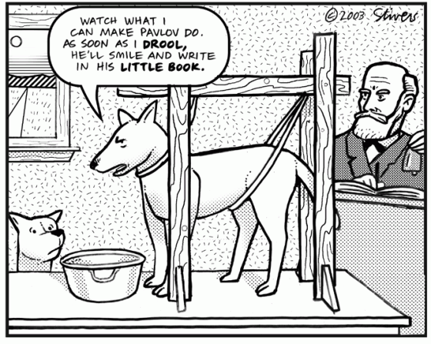
PSYCHOLOGY

Psychology is the systematic study of thoughts, feelings and behaviour. As a science, Psychology aims to describe, explain and predict behaviour; in doing so, it relies on empirical procedures rather than intuition. The application of research methods in Psychology allows students to develop useful skills in analytical and critical thinking and in making inferences. Possible career pathways include counseling, social work and sport/forensic/clinical psychologist.

UNITS 1 AND 2
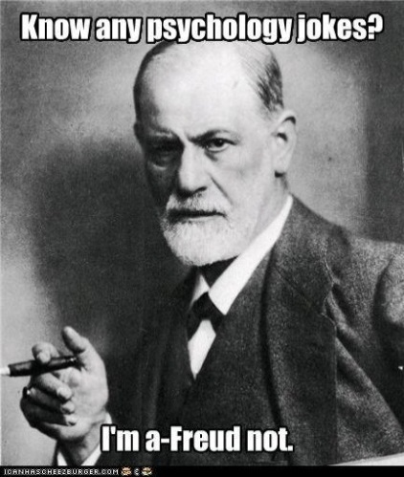
In these units students are introduced to the development of psychology from its philosophical beginnings to a scientific study of the human mind and behaviour. Students study the attitudes of individuals and how behaviours of groups can inform and contribute to explanations of individual aggression or altruism, the positive and negative power of peer pressure and responses to group behaviour.

Assessed Tasks:
Assessment tasks for these units are criteria based and consist of:
- Essay, annotated poster, multi-media presentation, empirical research activity (ERA), tests– short answer and extended response.

UNITS 3 AND 4
These units focus on the study of the relationship between the brain and the mind through examining the basis of consciousness, behaviour, cognition and memory. Students discover the mechanisms of learning and the cognitive processes that affect readiness for learning. Students also learn to explore the causes of mental illness, avenues of assistance and factors that promote mental wellbeing.
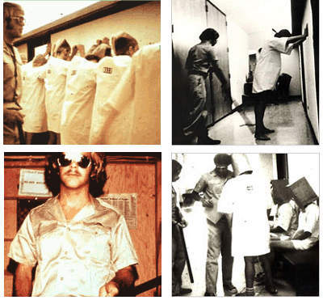
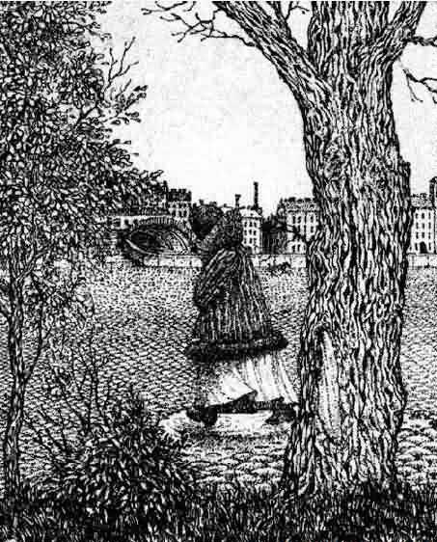

Assessed Tasks:
Assessment tasks for these units are criteria based and consist of any one, or a combination, of the following:
- Empirical Research Activity (ERA), annotated poster, multi-media presentation, summary and evaluation of data from previous research, tests (multiple choice, short answer and extended response) and folio of research activities.

Unit 3 SAC scores contribute 20%
Unit 4 SAC scores contribute 20%

VCAA ASSESSMENT:
All outcomes in Units 3&4 are examined in an end of year exam. This is worth 60%
