THEATRE STUDIES

UNIT 3: PRODUCTION DEVELOPMENT

This unit focuses on an interpretation of a playscript through the four designated stages of production: planning, production development, production season and production evaluation. Students will focus on two areas of stagecraft.

Stagecraft includes: acting, costume, direction, dramaturgy, lighting, make-up, multimedia, properties, promotion (including publicity), set, sound and stage management. Students research and apply acting and other stagecraft to interpret playscripts.
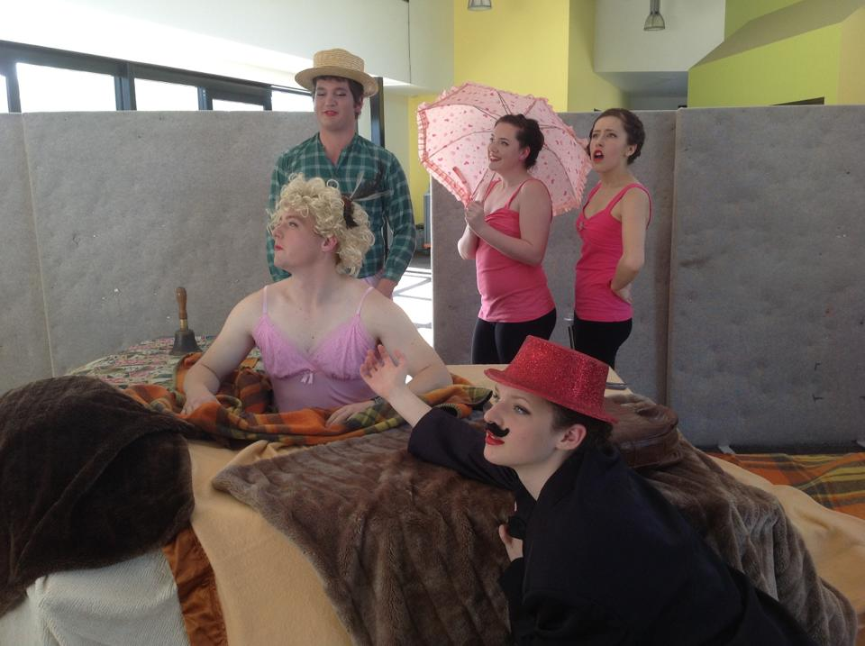

Areas of Study 1:
Production process: This area of study focuses on the development of skills which contribute to the interpretation of a playscript. Students develop an understanding of, and refine the skills necessary to contribute to the stages of the theatre production process. Examples include contribution to the production, working in collaboration with others, time management, organization, production management, scheduling and planning.

Area of Study 2:
Stagecraft influence: This area of study focuses on the analysis of the use of stagecraft in the playscript developed for production.

Area of Study 3:
Analysing a play in performance: This area of study focuses on an analysis of a professional performance of a playscript in a production from the prescribed Theatre Studies Unit 3 Playlist.

UNIT 4 : PERFORMANCE INTERPRETATION
In this unit students study a scene and associated monologue from the Theatre Studies performance examination monologue list.

Stagecraft in this unit includes: acting, costume, direction, dramaturgy, make-up, multimedia, properties, set and sound.
Note, in this unit stagecraft does not include lighting, stage management or promotion (including publicity).

Area of Study 1:
Monologue interpretation. Students interpret a monologue from a playscript selected from the monologue list through the application of acting, stagecraft and other theatrical styles.

Area of Study 2:
Scene interpretation: Students prepare a theatrical brief that outlines their interpretation of a scene from the monologue list.

Area of Study 3:
Performance analysis: students analyse and evaluate a professional play in performance of a playscript from the prescribed playlist.

